Electricity Billing System

**Abstract: the aim of our project is to develop a system that is meant to computerize the work performed in the Electricity bill, record of consuming unit of energy, store record of the customer and previous bills.**

INTRODUCTION:

Electricity Billing System is an application developed in Java programming language. The project aims at serving the department of electricity by computerizing the billing system. It mainly focuses on the calculation of Units consumed during the specified time and the money to be paid to electricity offices. This computerized system will make the overall billing system easy, accessible, comfortable and effective for employees.

Problem and Solution Statement:

The current system is paper based. . The disadvantages of paper based system are that papers can get easily damaged by stain marks; they can be lost due to fire or accidents or can get lost in general. Hence, time and money is wasted. As paper based, any changes that need to be made in the result will require reprinting, leading to wastage. For small changes, reprinting the entire result is impossible. Changes cannot be made dynamically. It is inefficient to access a particular record from the stack of papers. This system is time consuming.

Benchmark (How this solution is better?):

As paper based, any changes that need to be made in the result will require reprinting , leading to wastage. For small changes, reprinting the entire result is impossible. Changes cannot be made dynamically. It is inefficient to access a particular record from the stack of papers. This system is time consuming. As system has been provided with all maximum possibility to make their task easier, so number of features has been made available to continue the task without any intervention. It will only not prepare the bill but also able to store data of each consumers, so that it can be accessed any time and if required can make modification as per requirement

1. OBJECTIVE

The firm handles all of the work manually, which is very tedious and mismanaged .The objective of our project is as follows:

1. To keep the information of Customer.
2. To keep the information of consuming unit of energy of current month
3. Can add new customer
4. We can generate bill
5. Paying bill
6. It promotes eco friendly environment minimizing the use of paper
7. IMPLEMENTATION

We have used Java Programming language for this project. We have used Net Beans 8.2 IDE. My SQL is used for Database.

Firstly the employee needs to login in the system, after that he can add consumers, know their details, can generate and also accept payment.

1. Features:

* To make the billing system more service-oriented and simple, the following features have been implemented in the project.
* The electricity billing software calculates the units consumed by the customer and makes bills.
* It has the provision of security restriction.
* It requires small storage for installation and functioning.
* We can access details of consumer any time.
* We can accept the payment

Login Terminal:

Application Preview: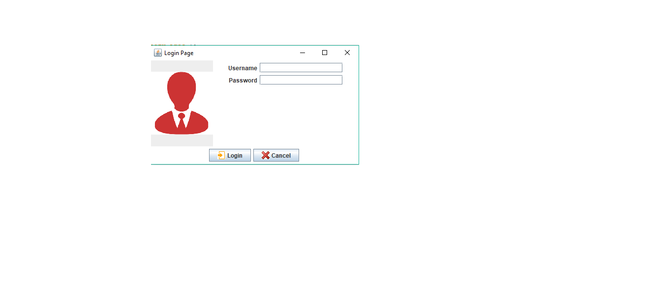

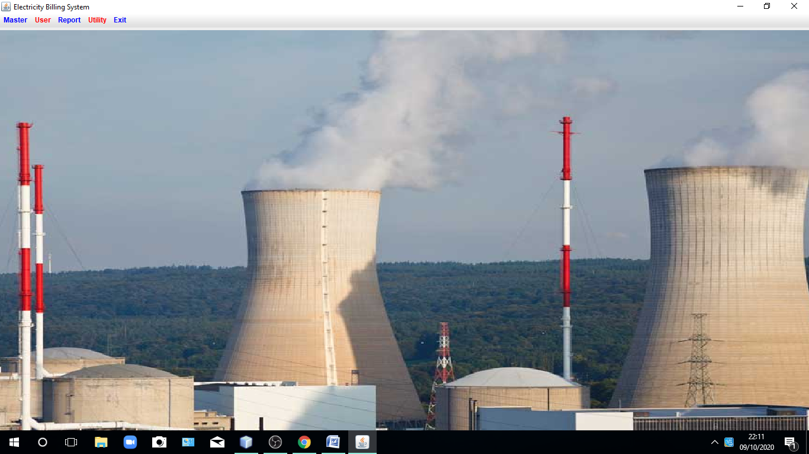

1. CONCLUSION:

A new software system to modernize the electricity billing procedure is required. This electricity billing system project would replace the existing traditional and analog type of electricity billing system ensuring security, ease and comfort in billing. It meets the current user demands, and new features can be easily integrated into the system in future as per user requirements.